**Commercial User permission rule**

1. **Indent creator**:

Application user will raise indent. He/She will must have checked Employee.

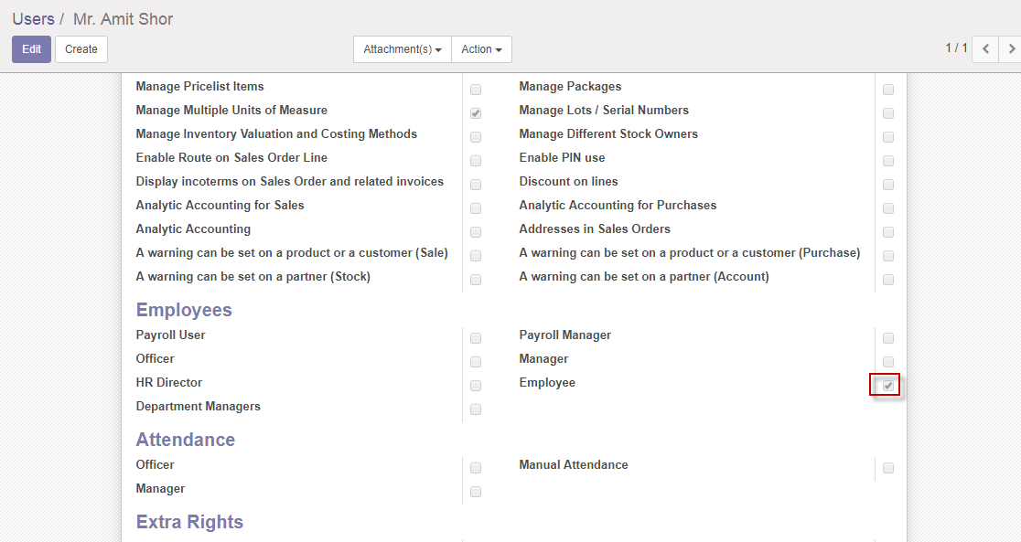

1. **Indent Approver**:

Indent Approver will approve indent. He/She will must have checked Indent approver.

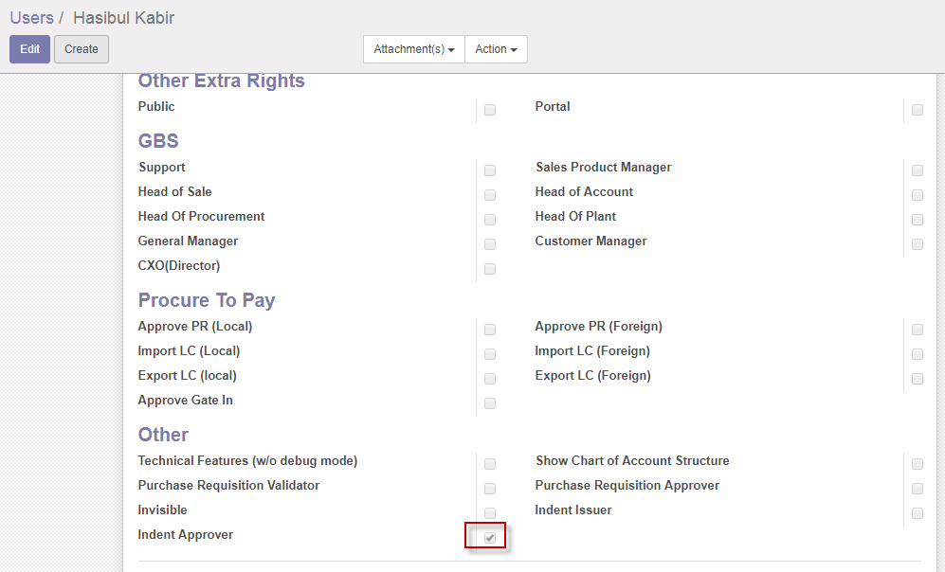

1. **Purchase Requisition Issue**r:

Inventory User or Manager will Issue Purchase Requisition. This user also may collect Purchase Quotation (if needed). He/She will must have Select Inventory User or Manager.

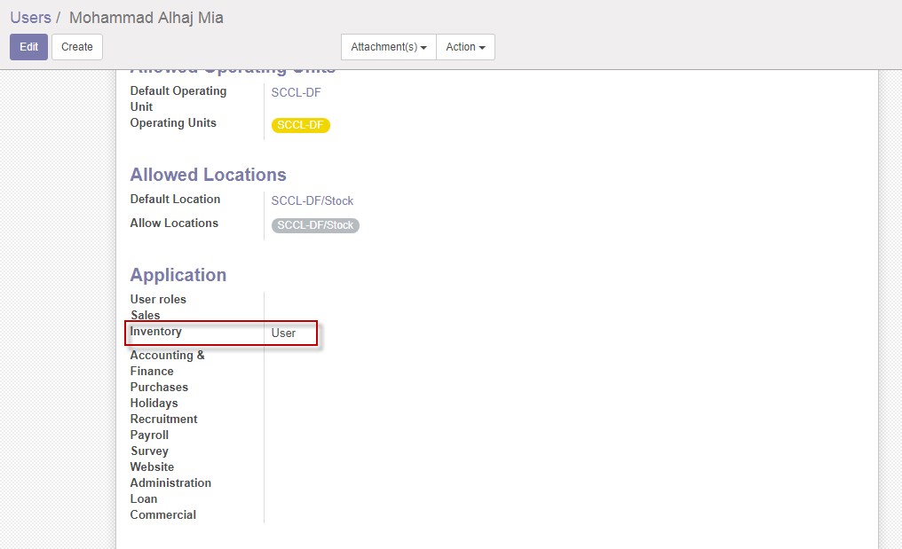

1. **Purchase Requisition Validator**:

This user will validate PR. This user also may collect Purchase Quotation (if needed). He/She will must have checked (Purchase user, Head of plant and Purchase Requisition Validator).

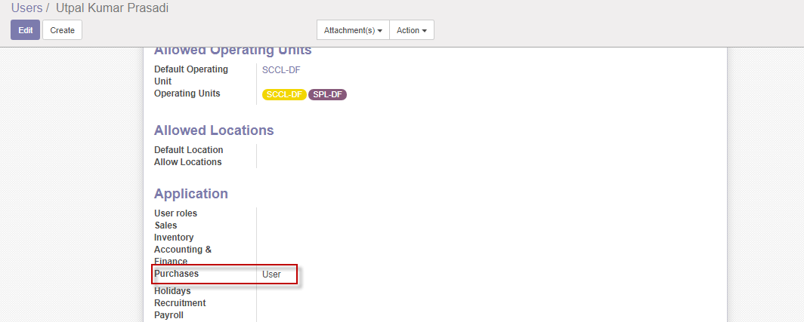

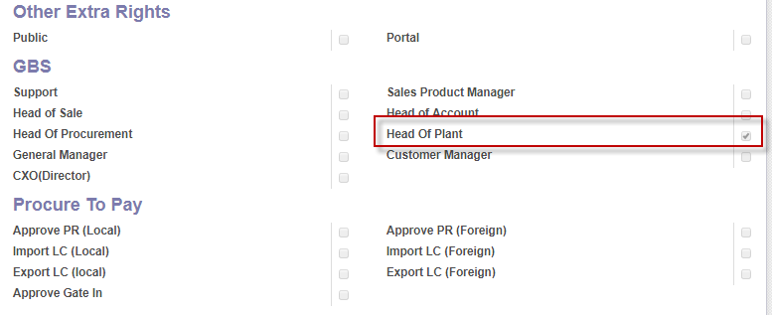

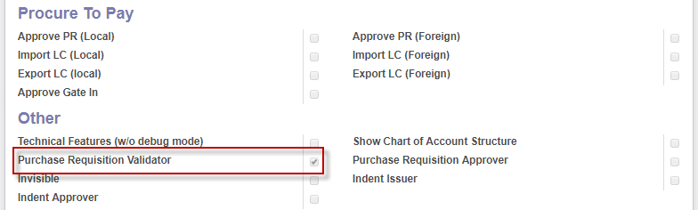

1. **Issue PR Approver**:

This user will approve Issue PR. This user also may collect Purchase Quotation (if needed). He/She will must have checked (Purchase Manager and Purchase Requisition Approver).

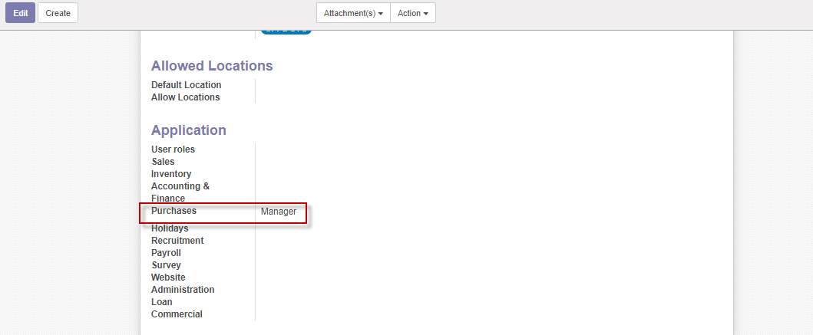

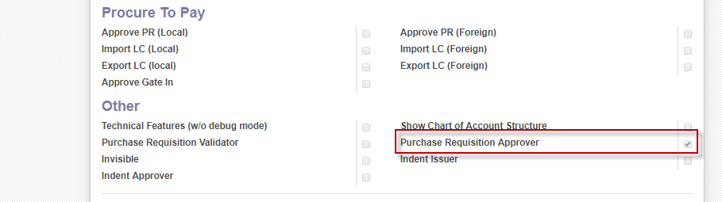

1. **New Quotation Initiator**:

This user will initiate new quotation. This user also may collect Purchase Quotation (if needed). He/She will must have checked (Purchase Manager and Purchase Requisition Approver).





1. **Confirm Order(PO Approve**d):

Commercial User will confirmed order or PO approved. He/She will must have Selected (Commercial Manager).

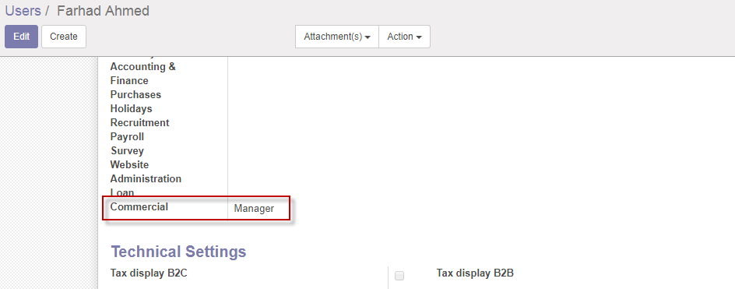

1. **Import LC(Local & Foreign):**

Commercial User will Create Import LC local and Foreign. He/She will must have Selected (Commercial user). Manager also capable to LC create. Commercial user also will do amendment, Shipment, C&F clear etc. Local & Foreign LC Individual user will create. Which have different permission for Local & foreign.

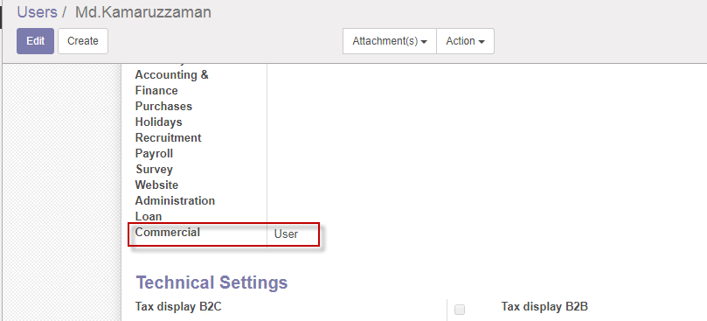

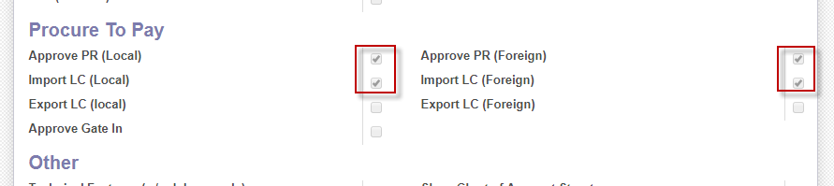

1. **Gate in(Gate in Approver):**

Gate in approver will do Gate in.He/She must have checked gate in.

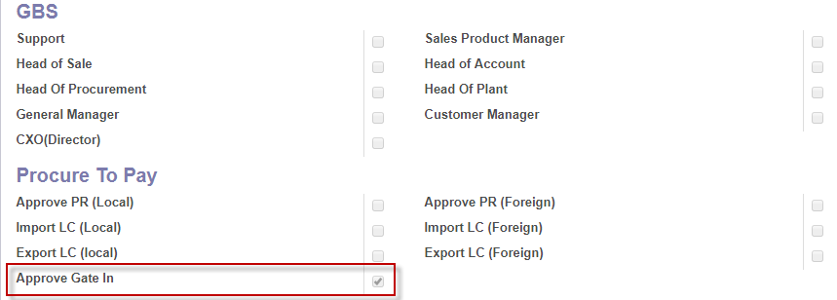

1. **Shipmen done:**

Commercial user will do Shipment done. He/She must have checked Commercial user.



1. **LC done:**

Commercial user will do LC done. He/She must have checked Commercial user.

